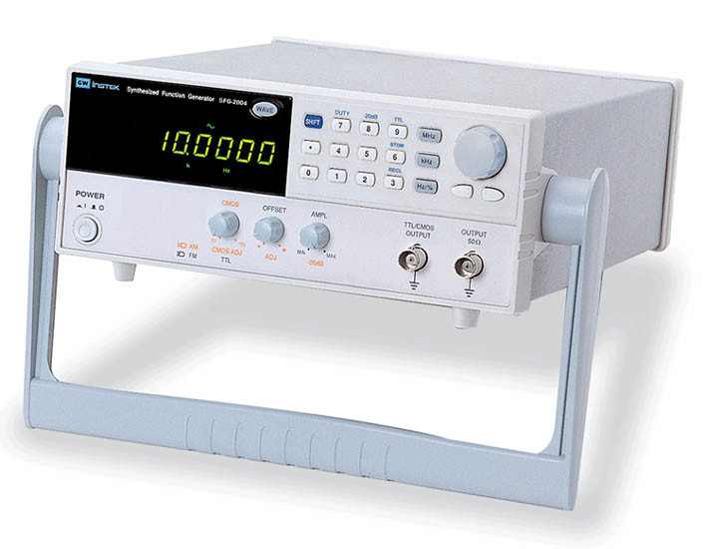
Station A Instructions
The frequency generator is connected to a speaker. The Range Hz setting on the frequency generator
should be on the 100Hz setting, Push the ON button to start. Listen to the frequency generated.
Then adjust the frequency dial to produce different tones.

Switch the setting to 1Hz. Then adjust the frequency dial to 1. Place your finger lightly on the speaker cone and describe what you feel. Then try adjusting the frequency dial to 2 and 3 etc and describe the changes in what you feel with the speaker cone.

Switch the setting to 10 Hz – adjust the frequency dial to 1. Place your finger on the speaker cone and try adjusting the frequency dial. How are the results similar to the previous 1 hz setting? How is is different?

Switch the setting to 100 Hz and adjust the frequency dial. Then try higher Hz values. What causes a higher frequency sound?

Station B Instructions
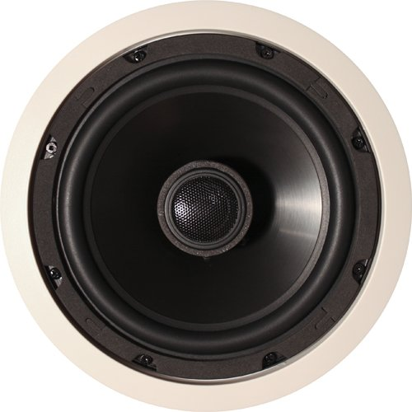
Examine the speaker provided. Two wires are attached to the terminals of the speaker. Touch the ends of these wires to the + and – terminals of the 9V battery provided. Describe what happens to the speaker.

What happens when you disconnect the wire from the battery?

Switch the wires on the 9V battery. What changes in the speaker?

Now attach the hand generator wires to the leads of the speaker. Wind the handle clockwise on the hand generator. Then wind it counterclockwise. In each case, what effect does it have on the speaker?

Why do you think causes the speaker cone to move up or down?

Station C Instructions
Clip the wires from the radio to the ends of the coil. The coil should be taped to the bottom of a cup.
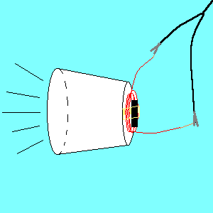
Place a magnet close to the coil on the bottom of the cup and place your ear near the open end of the cup. Listen and describe what you hear. Bring the magnet closer and further from the coil. What effect does the position of the magnet have on the sound produced? Why do you think this happens?

Now gently remove the coil from the bottom of the cup. Try attaching the coil to another solid surface, bring the magnet close to the coil and listen carefully. Describe the results. How do they compare to the cup?

How do you think causes all the complex vibrations you hear when you are listening to the radio broadcast through the coil and the magnet?

Station D Instructions
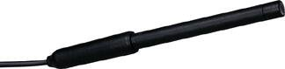
The Vernier microphone is operating with a program to take continual samples of sound. Activate the tuning forks by striking the tines against the hockey puck (not too vigorously). Then place the end of the microphone close to the tuning fork (without touching) and click to COLLECT data. Click to stop collecting and the pattern will be captured.

To determine the frequency of the sound, according to the computer display, select a point at the top of one of the crests and click. Drag across to the top of the 10th crest. Since the x-axis is displaying time, you should see a display (along the bottom) of the Δt for the 10 crests. Use this to calculate the frequency (= cycles/time).
Show your calculation. How does this compare to the frequency displayed on the tuning fork? Which is likely more precise?

Repeat this with the other tuning fork. Find its frequency by measuring 10 cycles. Show your data.

Sketch two sine curves to show how the two tuning fork patterns would differ:
Tuning fork 1 512 Hz Tuning fork 2 256 Hz

